OSCILLATOR MODULE (WITH
FAIL-SAFE CLOCK MONITOR)

Clock sources can be configured from external oscillators, quartz crystal resonators, ceramic resonators and Resistor-Capacitor (RC) circuits. In addition, the system clock source can be configured from one of two internal oscillators, with a choice of speeds selectable via software.

The Oscillator module can be configured in one of eight
clock modes.
1. EC – External clock with I/O on OSC2/CLKOUT.
2. LP – 32 kHz Low-Power Crystal mode.
3. XT – Medium Gain Crystal or Ceramic Resonator Oscillator mode.
4. HS – High Gain Crystal or Ceramic Resonator mode.
5. RC – External Resistor-Capacitor (RC) with FOSC/4 output on OSC2/CLKOUT.
6. RCIO – External Resistor-Capacitor (RC) with I/O on OSC2/CLKOUT.
7. INTOSC – Internal oscillator with FOSC/4 output on OSC2 and I/O on OSC1/CLKIN.
8. INTOSCIO – Internal oscillator with I/O on OSC1/CLKIN and OSC2/CLKOUT.

Oscillator Control
The Oscillator Control (OSCCON) register controls the system clock and frequency selection options. The OSCCON register contains the following bits:
• Frequency selection bits (IRCF)
• Frequency Status bits (HTS, LTS)
• System clock control bits (OSTS, SCS)

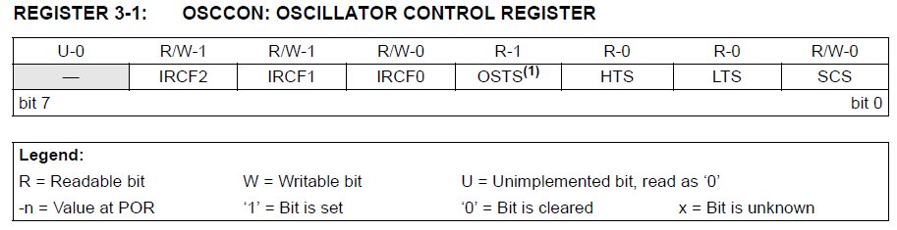

bit 7 Unimplemented: Read as ‘0’

bit 6-4 IRCF<2:0>: Internal Oscillator Frequency Select bits
111 = 8MHz
110 = 4 MHz (default)
101 = 2MHz
100 = 1MHz
011 = 500 kHz
010 = 250 kHz
001 = 125 kHz
000 = 31 kHz (LFINTOSC)

bit 3 OSTS: Oscillator Start-up Time-out Status bit(1)
1 = Device is running from the external clock defined by FOSC<2:0> of the CONFIG register
0 = Device is running from the internal oscillator (HFINTOSC or LFINTOSC)

bit 2 HTS: HFINTOSC Status bit (High Frequency – 8 MHz to 125 kHz)
1 = HFINTOSC is stable
0 = HFINTOSC is not stable

bit 1 LTS: LFINTOSC Stable bit (Low Frequency – 31 kHz)
1 = LFINTOSC is stable
0 = LFINTOSC is not stable

bit 0 SCS: System Clock Select bit
1 = Internal oscillator is used for system clock
0 = Clock source defined by FOSC<2:0> of the CONFIG register

Note 1: Bit resets to ‘0’ with Two-Speed Start-up and LP, XT or HS selected as the Oscillator mode or Fail-Safe mode is enabled.

